Software Analysis to Design
Lab 3



Seán, O’Malley
B00150952

Russel Makani
B00164413

Department of Engineering
School of Informatics & Engineering
Institute of Technology, Blanchardstown
Dublin 15.

Software design and quality
Contents
Introduction 2
Problem Statement 3
Software Analysis 3
Use Case Analysis 3
Fully Dressed Use Case: View Historical Weather Data 3
UML Class Conceptual Model 5
Modelling Assumptions 5
Behaviour analysis 6
System Design Observations and Recommendations 10
Software Design 11
Interaction Analysis 11
Detailed Sequence Diagrams 11
Refined Class Diagram 15

Figure 1. 5
Figure 2. 6
Figure 3. 7
Figure 4 8
Figure 5 9
Figure 6 10
Figure 7 11
Figure 8 11

Introduction
In this document, we present the complete software analysis and design for a simple weather station system. This work represents the progression from initial requirements analysis through conceptual modelling to detailed software design.
The analysis phase focuses on understanding what the system does through use case modelling, domain concept identification, and behaviour analysis. The design phase translates these analysis artifacts into detailed interaction models and refined class structures that can guide implementation.
Requirements analysis and conceptual modelling are collaborative exercises that help discover problem domain concepts forming the basis of our software classes. Visual models ensure that requirements and designs are unambiguous before implementation occurs.
This document serves as comprehensive communication between team members and stakeholders, capturing all key decisions, assumptions, and design rationale developed throughout the analysis and design phases.

Problem Statement
You have been tasked with designing the software system for a simple weather-station. A
weather station records local weather information and periodically transfers this to a
weather information system using a satellite link. Currently the system keeps track of
temperature, wind speed (Anemometer) and pressure (barometer) but must be flexible
enough to be expanded at a later stage.
The system is composed of a basic Micro-controller, a single temperature sensor, a display,
memory bank and user buttons.
The system displays temperature readings in real time on the display. It also keeps track of
historical information on an hourly and daily basis. This historical data can be pulled up on
the display at the request of the user by pressing the appropriate button.

Software Analysis

Use Case Analysis

Fully Dressed Use Case: View Historical Weather Data
Use case name: View Historical Weather Data
Scope: Weather Station System
Level: User-goal level Primary
Actor: User

Stakeholders and Interests:
- The user wants to view accurate historical weather data.
- The system must store and retrieve data reliably.

Preconditions:
- The system is powered on.
- Sensors are actively recording.
- Historical data exists in memory.

Postconditions:
- Historical data is displayed.
- The system remains stable and ready for further input.
Main Success Scenario:
- The user presses the “History” button.
- The system displays options: Hourly or Daily.
- The user selects “Daily”.
- The system retrieves daily data from memory.
- The system displays the data on screen.

Extensions:
- If the user presses the wrong button, the system ignores the input or prompts for correction.
- If no data is available, the system displays “No historical data available.”

Special Requirements:
- The display must be readable outdoors.
- Data retrieval must be fast (less than 2 seconds).
- The system must support future sensor expansion.

UML Class Conceptual Model
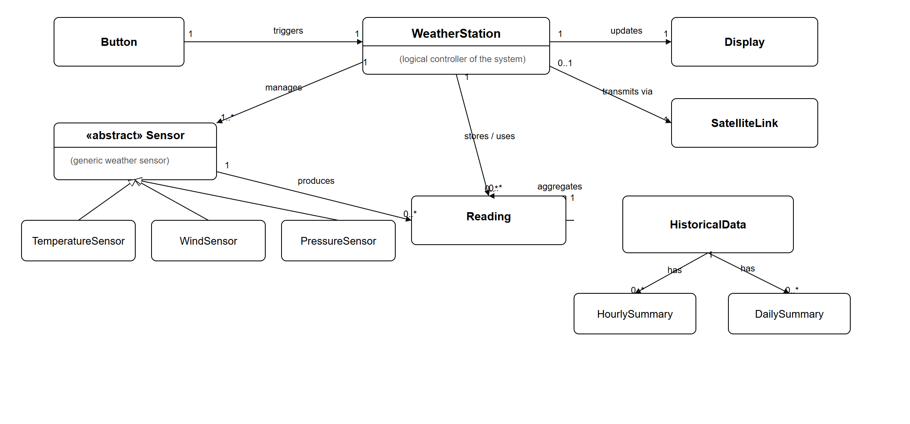

Modelling Assumptions
- General Sensor Abstraction
The term Sensor is treated as an abstract conceptual class representing any physical device capable of producing a weather-related reading.
TemperatureSensor, WindSensor (Anemometer), and PressureSensor (Barometer) are modeled as specializations.
This abstraction assumes future sensors (e.g., humidity, rainfall) can be added without modifying the overall structure.
- Single WeatherStation Controller
The system is assumed to be managed by a single controlling unit (WeatherStation/microcontroller) responsible for coordinating reading collection, historical data organisation, display updates, and satellite communication.
No distributed or multi-controller coordination is assumed.
- Readings as Domain Objects
Each measurement (temperature, wind speed, pressure) is assumed to be represented as a conceptual Reading entity that exists independently of the sensor once captured.
These readings are assumed to be timestamped and stored for later retrieval.
- Historical Data Grouping
HistoricalData is assumed to aggregate all readings and produce summaries
It is assumed that the calculation rules for hourly and daily summaries (e.g., average, max/min) are part of the conceptual domain but not the design at this stage.
- Display as a Passive Output Device
The display is assumed to have no internal storage or processing capability.
It only shows information that the WeatherStation sends to it.
- Button as a Simple Event Trigger
The Button is assumed to be a simple user input mechanism that generates press events.
It does not process logic, interpret commands, or store state — it merely notifies the WeatherStation.
- SatelliteLink as a Logical Connection
The satellite communication link is treated as a conceptual channel for transmitting summary data.
No assumptions are made about real-world network conditions, bandwidth limits, or communication protocols.
- Continuous Operation and Reliable Power
It is assumed that the system is powered continuously and capable of periodic measurement without interruptions.
Battery behaviour, low-power modes, or failures are not modelled at the conceptual level.
- Data Always Available Unless Stated Otherwise
Except where explicitly shown in alternative flows, it is assumed that readings, summaries, and historical data are available when requested.
Data corruption, missing data, or storage failures are outside the scope of the conceptual model.
- Timekeeping Available
The system is assumed to have access to consistent timekeeping (e.g., an internal clock) for timestamps, hourly grouping, and daily summaries, even though the clock is not modelled as a separate entity.

Behaviour analysis

Sequence Diagram
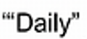
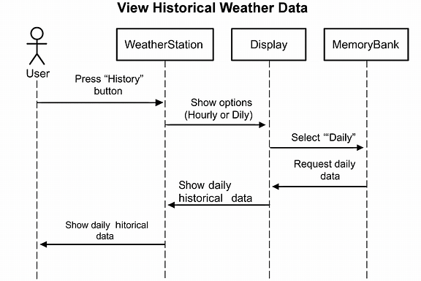
Figure 1.

High-Level Activity Diagram
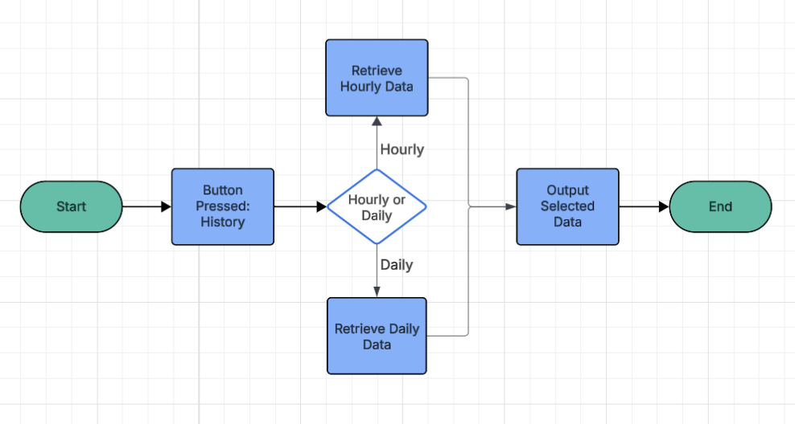
Figure 2.

High-Level State Diagram
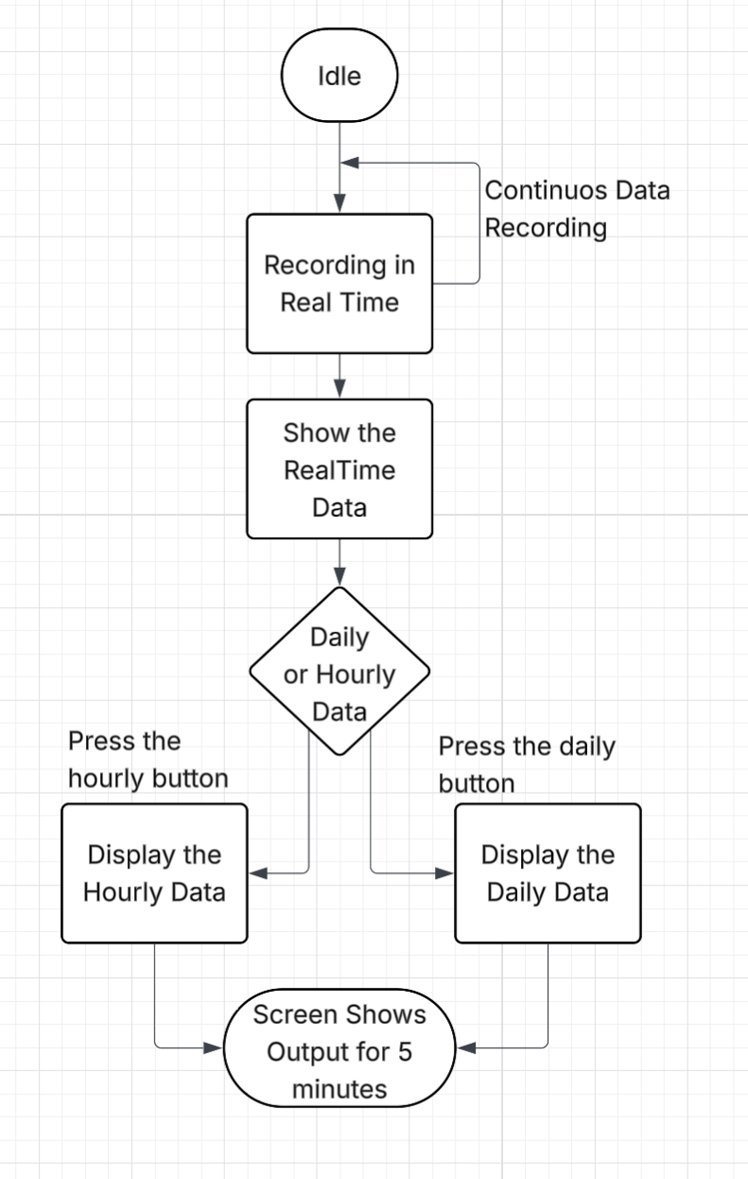
Figure 3.

System Design Observations and Recommendations

System Design Observations
- Centralised Control
The WeatherStation (microcontroller) acts as the core coordinator for all system activity, including data collection, storage, display updates, and communication. This central role simplifies system behaviour but increases controller responsibility.
- Clear Separation of Real-Time and Historical Data
The system handles real-time sensor readings and historical data independently. This separation indicates different storage and performance requirements for each type of data.
- Sensor Abstraction Supports Extensibility
Using an abstract Sensor concept allows new sensor types (e.g., humidity) to be added without major system changes.
- Need for Efficient Data Organisation
Historical readings accumulate over time, meaning the MemoryBank must organise and retrieve data efficiently to support hourly and daily summaries.
- Simple User Interaction Model
The user interacts only through button presses, and the WeatherStation interprets these events. This keeps the UI simple but places more logic on the controller.
- External Communication Is High-Level
The SatelliteLink is treated as a conceptual connection without specifying real-world constraints. This leaves flexibility for later design decisions.

Design Recommendations
- Modularise the WeatherStation Logic
Break the controller’s responsibilities into clear modules (sensor handling, data storage, display formatting, communication) to improve clarity and maintainability.
- Use a Strategy Pattern for Sensors
Implementing a common interface for all sensors will simplify the addition of future sensor types.
- Optimise Historical Data Storage
Use efficient data structures (e.g., circular buffers or trimmed logs) to prevent memory overflow and ensure fast access to historical data.
- Precompute Summaries
Generate hourly and daily summaries periodically so they can be retrieved quickly when the user requests them.
- Implement Basic Error Handling
The system should detect missing or invalid sensor readings and provide safe fallback behaviour (e.g., show a message instead of freezing or crashing).
- Support Intermittent Communication
Add retry and acknowledgement checks for satellite transmission to ensure data is sent reliably in real-world conditions.
- Use Clear Display Modes
Indicate when the system is showing real-time, hourly, or daily data to avoid user confusion.

Software Design

Interaction Analysis

Detailed Sequence Diagrams
Below are the detailed sequence diagrams required for the design phase

Sequence 1 – User Views Real-Time Data
Description:
This sequence describes how the system responds when the user requests current weather conditions. It includes the flow of sensor readings, internal processing, and display output.
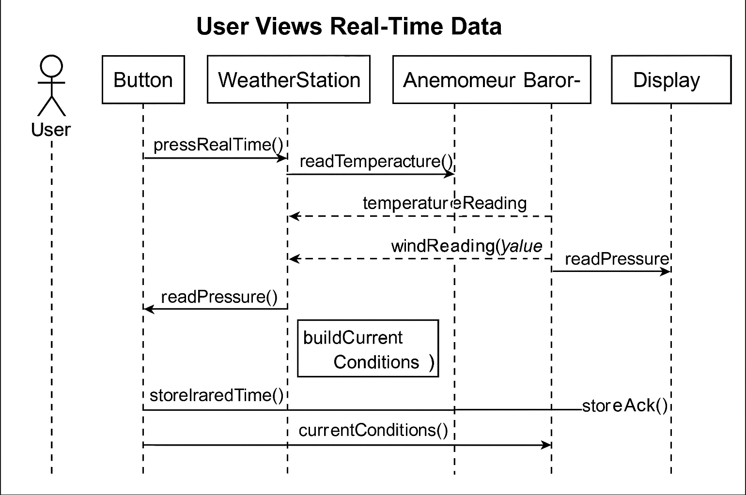
Figure 4

Sequence 2 – System Records Periodic Data
Description:
This sequence shows how the system automatically records weather measurements at scheduled intervals without user interaction.
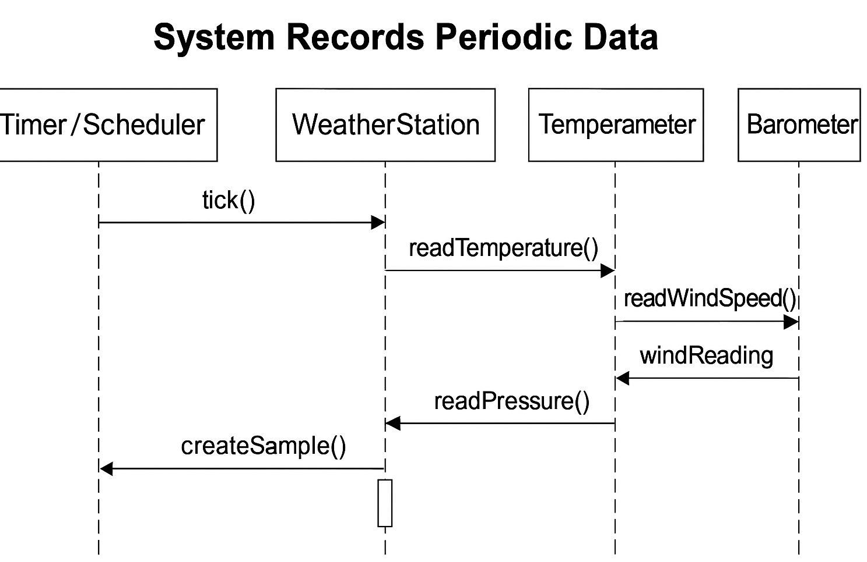
Figure 5

Sequence 3 – User Views Historical Data (Hourly or Daily)
Description:
This sequence covers both hourly and daily historical data requests and expands on the high-level version
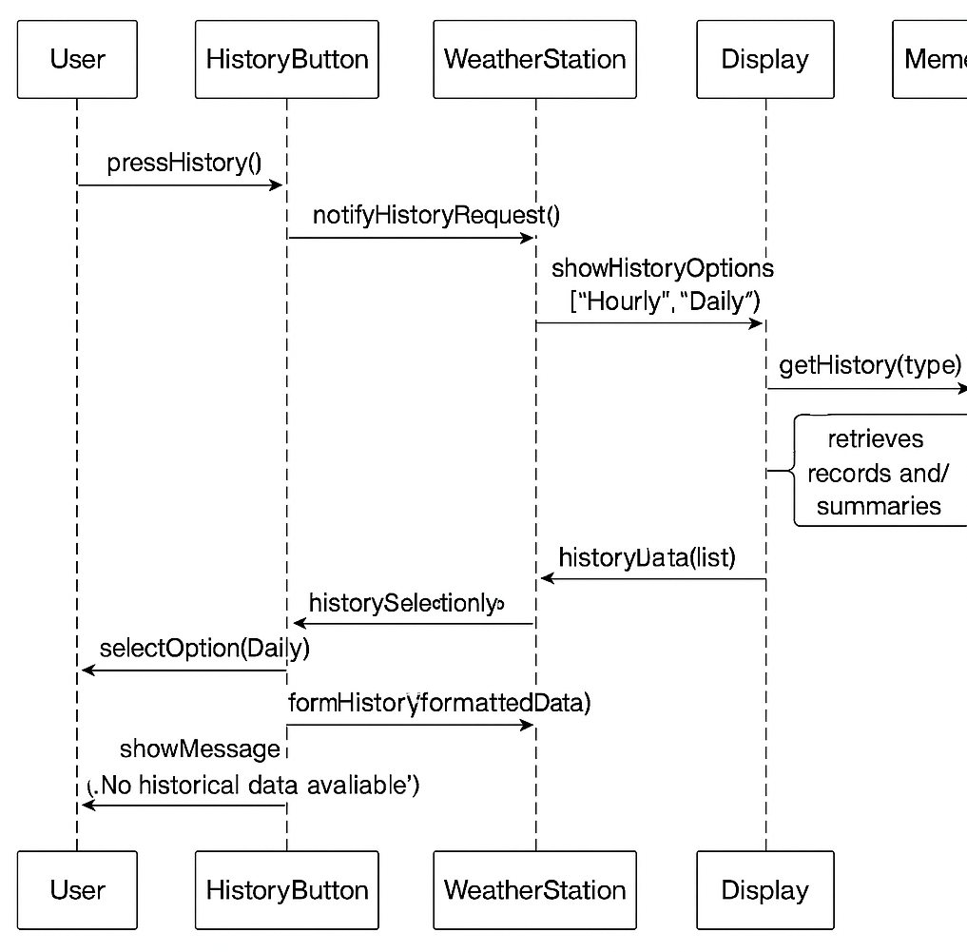
Figure 6

Sequence 4 – System Transmits Data via Satellite
Description:
Shows the periodic upload of summary data via satellite link.
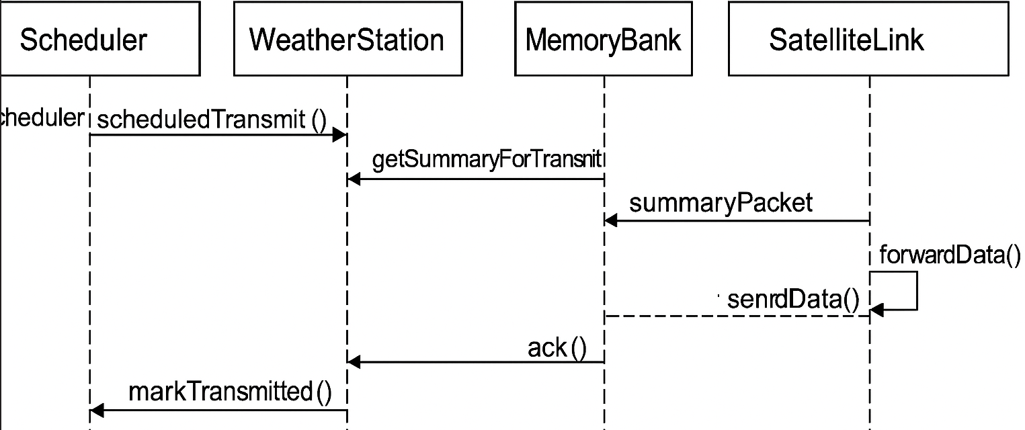
Figure 7

Refined Class Diagram
The refined class diagram expands the conceptual model from Lab 2 by adding attributes, methods, access visibility, and clarifying associations.
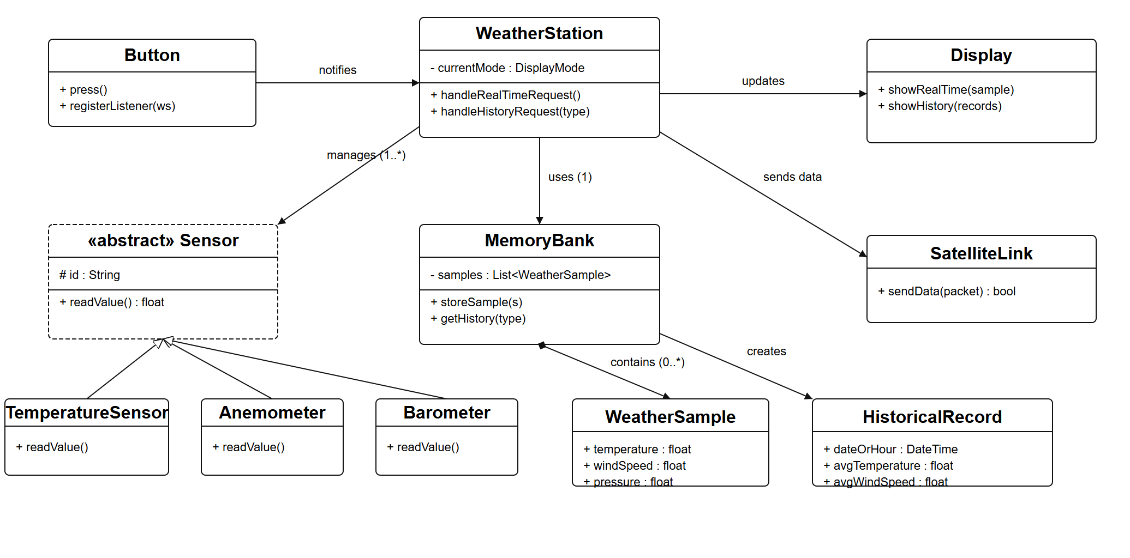
Figure 8

Implementation Recommendations & Notes
The system should be implemented using a modular structure that separates sensor handling, data storage, display control, and communication. A common sensor interface is recommended to allow easy expansion with new sensor types. Historical data should be stored efficiently—such as through circular buffers—and hourly or daily summaries should be precomputed for fast retrieval. The system should also include basic error handling for missing or invalid sensor readings and use simple retry and acknowledgement checks for satellite communication. Clear display modes should be implemented to differentiate real-time and historical views, and the overall design should remain flexible to support future enhancements or additional functionality.

